Clean C++20: Sustainable Software Development Patterns and Best Practices
By Stephan Roth
Notes:
“IDEA” – Keyphrase to denote when I had an idea to be able to use in the future
Bold – Any code references made in notes
Underline – New words/phrases and definitions

Chapter 1 - Introduction

Notes
- Software entropy – every time a function is added or something changed, the code gets a little bit more disordered
  - Lots of factors contribute to this like bad/rushed schedules and developer experience, as well as quick and dirty hacks to problems
- Clean code is the foundation to sustainable software. Will help in the long run, and make your job more stress free and saves money

Chapter 2 – Build A Safety Net

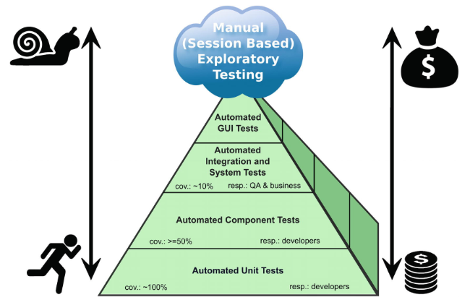
Notes
- The ideal test pyramid to creating robust and strong software

Unit Tests
- Unit test – piece of code that executes a small portion of production code in a particular context (functions, methods, etc)
  - Why?
    - Many studies show fixing bugs after release is much more expensive
    - Give immediate feedback and know in just a few seconds if the code works properly
    - Give confidence that if a dev changes the code, if the tests succeed then all is good
    - Can detect regressions in development to know if the path you’re going down is good
    - If a piece of code can be mounted against a test fixture, then it can also be easily integrated with less effort into the system’s production code
- Good unit tests help devs understand a piece of code written by someone else and trust everything still works normally
THIS NOW GOES INTO RULES FOR GOOD TESTS, UNIT TEST naming, Unit test independence, etc. I skipped this right now because I don’t plan on doing unit tests right now for my low skill level

Don’t Mix Test Code with Production Code
- Mixing test code with production code increases complexity and reduces readability, which is important for coming back to code later
- Solutions can be constructing an instance of a class all together and giving it test values, INSTEAD of making an instance of a class and passing only a test parameter
SKIPPED Tests must run fast, How do you find a tests input data, equivalence partitioning, boundary value analysis, test doubles.

Chapter 3 – Be Principled

Keep It Simple Stupid - KISS
- Keep it simple, stupid.
- Do not overplay simplicity, if 10 decisions are necessary in a switch statement, and there is no better solution, that’s just how it is

You Ain’t Gonna Need It - YAGNI
- Implement things when you actually need it, never when you just foresee you might need them

Don’t Repeat Yourself - DRY
- Any copied piece will be forgotten sooner or later and can lead to bugs
- Use inheritance to get rid of duplicated classes and the like, or use C++ templates

Information Hiding
- One piece of code that calls another piece of code should not know the internals of the other. This allows the definitions to be changed if needed, and NOT change each call of the function
- Advantages of info hiding:
  - Limitation of the consequences of changes in modules
  - Minimal influence on other modules if a bug fix is necessary
  - Significantly increasing the reusability of modules
  - Better testability of modules
- Information hiding with enumerations/return types can be done in a class example
  - enum class State {open, closed, opening, closing};
  - Create a function bool isOpen() in the public access of the class INSTEAD of having outside functions know that state is even an enum.

Strong Cohesion
- Any software entity should have strong cohesion. Strong cohesion is when the module does a well defined job
- Reduce dependencies on other pieces of modules of code

Loose Coupling
- Say there are two classes. Lamp is the parent of switch. Switch takes parameter reference to the lamp. This is not ideal. Loose coupling is when each module has little or no knowledge of the definitions of other separate modules
  - Can be solved with interfaces

